**Map chart showing countries with suicide no more than 50,000:-**

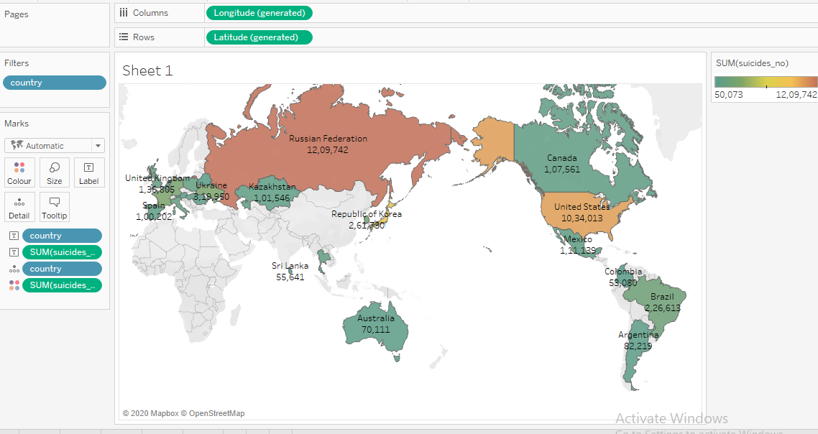

This chart is showing different countries with suicide numbers more than 50,000.colour shows sum of suicide numbers. Through this chart we can easily see which country has how many suicide cases. We can Russian federation has highest no. of suicide cases and Colombia has least no. of suicide cases according to our condition.

**Tree map shows details about countries and size shows sum of suicide numbers and how many males and females have died in respective countries:-**

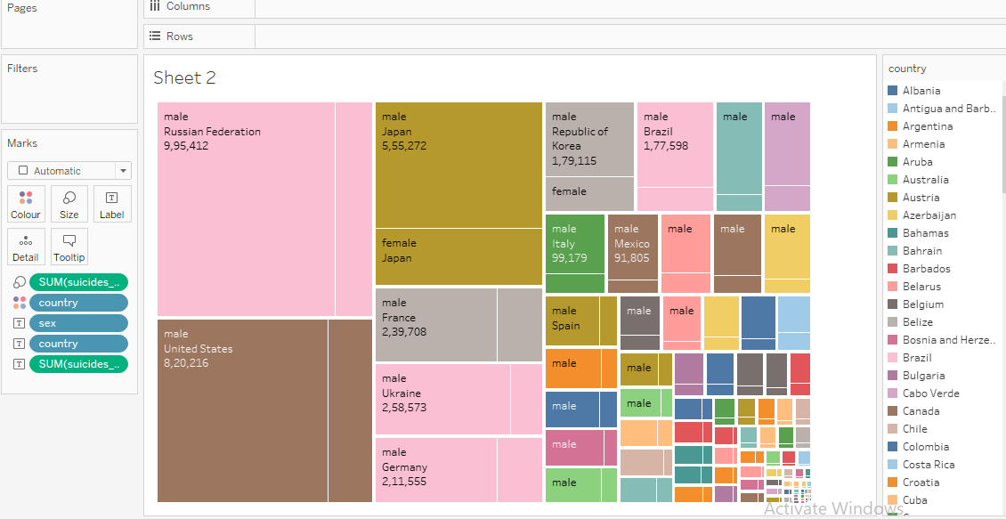

Country colours shows detail about country size shows sum of suicide numbers. Chart is showing suicide no. in different countries and how many males and females suicided in respective countries. Colour represents different country. For example In Russian federation 9,95,412 males suicided and rest were females.

**Pie chart which shows how many males and females died from different ages. over the years:-**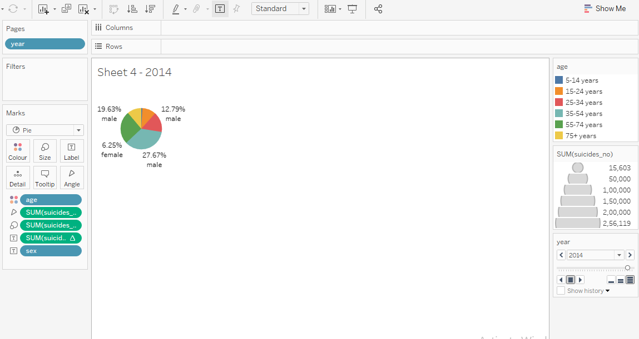

Percentage of Total suicides no. and sex. Colour shows details about age. Size shows sum of suicides no. The marks are labelled by percentage of Total suicides no. and sex. Chart shows suicide no. in male and female over the years. And size of pie will change according to data provided at that time.

**Motion chart which shows relationship between suicide numbers and different generations and the colour shows details about age over the years:-**

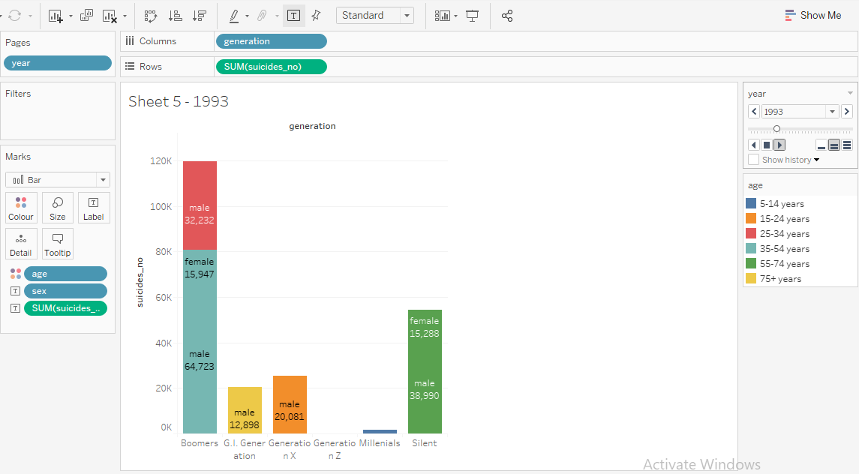

Sum of suicides no. for each generation. Colour shows details about age. The marks are labelled by sex and sum of suicides number .This chart shows how many suicides were there in different generation over the years and in which age group they belonged to.

**Area chart which shows relationship between different ages and percentile of suicide/100kpop in different years for Male and female**

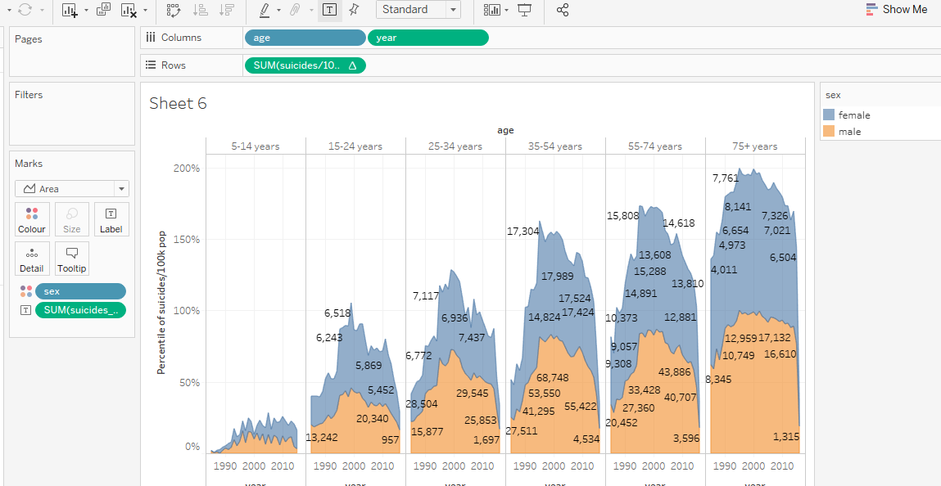

The plot of percentile of suicides/100kPop for year broken down by age .colour shows detail about sex the marks are labelled by sum of suicide numbers.

Dual chart showing sum of population and sum of suicide numbers from 1985-2015:-

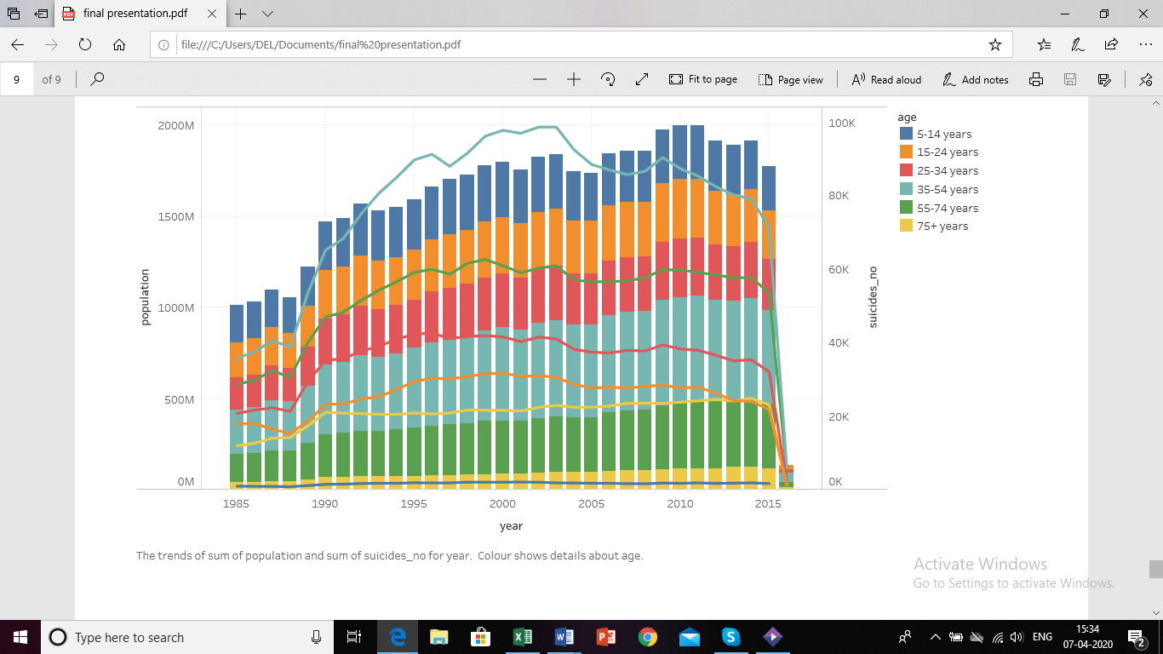

This chart is showing the sum of population and sum of suicides over the years where bar represents the sum of population and line represents the number of suicides over the years .we can see through this visualization no. of suicides is increasing drastically after year 1987. The colour shows details about age through this visualization we can see most of the suicides are done by people of age from 35-54 years